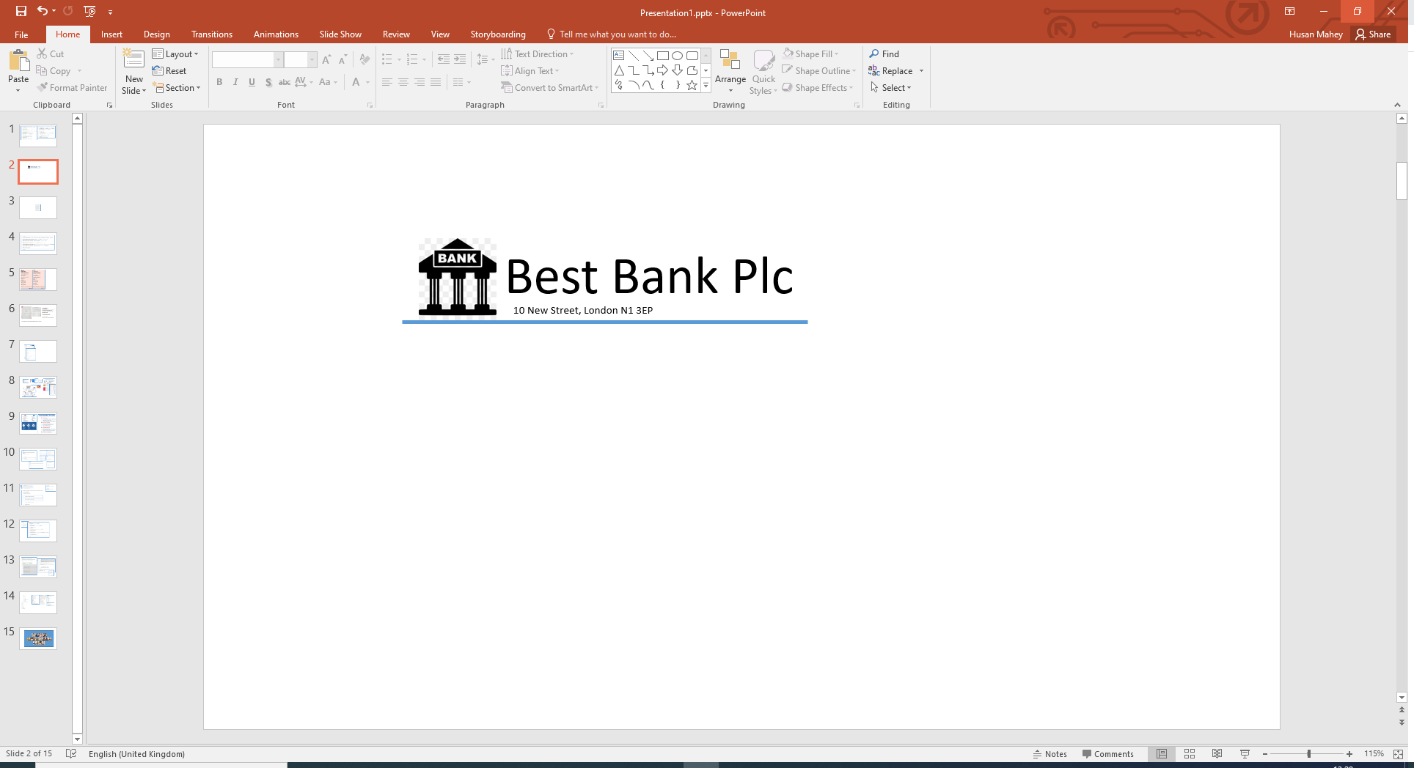

Mr John Pince

21 Hobart St

Parkham

Devon

EX39 5DJ

Our Ref: Q298

Dear John,

Congratulations! Based on the information provided by you, we are pleased to inform you that you have been pre-approved for your recent loan application.

**Loan Details**

Amount: £ 5,000.00

Term: 24 months

Interest Rate (APR): 3.40%

Total Payable: £ 5,176.08

Monthly Payment: £ 215.67